Quickdress: Design Specification
Milestone 2 · Sprint 1 · Revision 2, November 7, 2026
Prepared by Marwan Abouelfotuh
Team: Aya Noaman, Malk Metwally, Nada Salem, Marwan Abouelfotuh, Omar Hassan
This document is the companion to the Quickdress Requirements Specification. Requirement IDs (FR-xx, NFR-xx) refer to that document.

Change log
This specification is updated at the end of every sprint. In the body, rows shaded yellow and paragraphs that start with Changed in rev. 2 are new or changed in revision 2. Section 7 is new: it is the lower-level design of what Sprint 1 built.
Revision | Date | Section | What changed | Why
0 | October 13, 2026 | All | First version: layered architecture. | Milestone 1
1 | November 5, 2026 | All | Microkernel architecture; rules, tests and decision points behind every claim (Table 0). | Instructor comments on Milestone 1
2 | November 7, 2026 | Figure 1, Tables 1, 3, 7, 9 | Sprint 1 status marked on the component diagram. CapturePlugins gained SubjectLifter and ItemAnalyzer. The plug-in registry is not built yet. New risk R12. | End of Sprint 1
2 | November 7, 2026 | 2.3 | Adding an item described as built, with the cut-out and suggestions. | End of Sprint 1
2 | November 7, 2026 | 6.2 | Sprint 1 result against its exit criteria. | End of Sprint 1
2 | November 7, 2026 | 7 (new) | Lower-level design as built: differences from the plan, capture plug-ins and helpers, domain changes, sequence diagrams for adding, editing and deleting an item, class diagram of the built code, user interface design, and the tests that were run. | Milestone 2 asks for architecture and lower-level design changes
Change log.

What changed in revision 1
The first version (October 13, 2026) received two main comments from the instructor. Table 0 shows how revision 1 answers each one.
Comment | What we changed
A layered architecture is too simple for our app. | The app is now a microkernel (plug-in) architecture: a small core plus plug-ins for capture, storage, context, filters and recommenders, with an in-process event bus. Outfit generation is a pipe-and-filter pipeline inside the core. MVVM stays as the design of the screens. Every diagram, table and section that described the layers was rewritten (sections 1 to 7).
We make statements that we do not support with concrete plans. | Every promise now has a rule, a number or a test behind it: the scoring rules and thresholds (section 2.2), the formality keywords (section 2.2), a test plan with a sprint, a tool and a pass mark for each non-functional requirement (Table 6), exit criteria and a decision rule for stretch goals in the build order (Table 8), and a decision point for every risk (Table 9). The Core ML recommender, which had no data or plan behind it, was removed from this term's design.
Table 0. Instructor comments and the changes made.

Contents
- High-level architecture
- Explanation of the architecture
- Quality attributes and how we will test them
- Architectural and design patterns
- Detailed design: class diagram
- Technical feasibility, build order and risks
- Sprint 1: lower-level design as built (new in revision 2)
- Conclusion

1 High-level architecture

1.1 Overview
Quickdress is a single iOS app with no backend of its own. Wardrobe data, photos and calendar information stay on the phone. The app makes only two kinds of network call: one to a weather service for the forecast and, if the user opts in (FR-22), one to Google's Gemini 3.1 Flash-Lite model through Firebase AI Logic.
The app uses a microkernel architecture, also called a plug-in architecture. It has three parts:
- The core system. A small set of components that hold the rules that never change: what a valid clothing item is, how the day's context is put together, and how an outfit is produced. The core also owns the plug-in registry, where plug-ins are registered at launch, and the event bus, which tells interested components when something has happened. The core is plain Swift and imports no Apple framework apart from Foundation.
- Plug-ins. Everything that can vary or be replaced: where photos come from (camera or photo library), where data is stored (SwiftData, files), where the day's information comes from (WeatherKit, Open-Meteo, the calendar), which filters an outfit must pass, and which recommender picks the outfit (rule-based or Gemini). Each plug-in implements a contract (a Swift protocol) defined by the core and never calls another plug-in.
- The host app. The SwiftUI screens, built with MVVM (Model, View, ViewModel), and the composition root (QuickdressApp), which creates every plug-in and registers it with the core. ViewModels call only the core's public services.
The reason for this structure is that most of what is hard about Quickdress is choosing between interchangeable parts at run time. There are two weather sources (R1), two recommenders with a fallback between them (FR-22, NFR-03), two image sources, four outfit filters, and more parts that the backlog already plans for later, such as a laundry filter (FR-20) and iCloud storage (FR-21). In a microkernel these are all the same kind of thing: a plug-in with a priority and an availability check. The core decides which one to use, so adding or removing one does not change the core or any screen (NFR-08).
iOS does not allow an app to download and run new code (App Store Review Guideline 2.5.2), so our plug-ins are not loaded at run time. Each plug-in group is its own Swift package, compiled into the app and registered in code at launch. What makes it a plug-in is that the core depends only on the contract, and the plug-in is chosen by the registry, not by the caller.

1.2 Component diagram
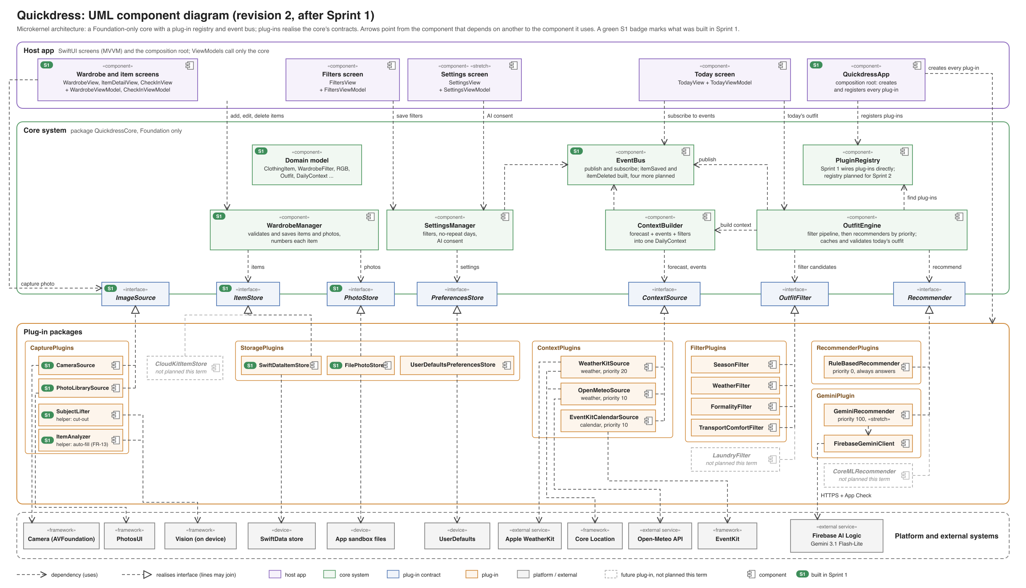
Figure 1. UML component diagram of Quickdress: the core system, its plug-in contracts, the plug-ins that realise them, and the host app. A green S1 badge marks what Sprint 1 built.

1.3 The core system
Table 1 lists the components of the core. All of them live in one Swift package, QuickdressCore, which has no dependency on any other package in the project. The compiler therefore stops the core from using a plug-in directly.
Component | Responsibility | Uses | Requirements
PluginRegistry | Holds every registered plug-in. Returns the plug-ins for a contract in priority order, filtered to those that say they are available. For contracts that need exactly one implementation (the stores), it returns that one and fails a launch test if it is missing. Not built in Sprint 1: QuickdressApp passes the plug-ins in directly (section 7.1). Planned for Sprint 2. | Plug-in contracts | NFR-08
EventBus | Delivers events (Table 4) to subscribers, on the main thread, in the order they subscribed. Events only report that something happened. They never carry a request that needs an answer. Sprint 1 built the bus with itemSaved and itemDeleted. | None | FR-09, NFR-01
WardrobeManager | Adds, edits and deletes items. Checks that the category is set, the colour is one of the 12 palette colours, ratings are 1 to 5 and at least one season is chosen. Saves the photo first and the item second, and deletes the photo again if the item fails to save. Publishes itemSaved and itemDeleted. Gives each new item the next tag number. | ItemStore, PhotoStore, EventBus | FR-01 to FR-03, NFR-06
ContextBuilder | Builds one DailyContext for a date: forecast, events, filters and the day's formality level. For each kind of context it tries the context plug-ins in priority order, with a 3-second limit each, and falls back to cached or default values (section 2.1). Publishes contextDegraded when it had to fall back. | Context plug-ins, PreferencesStore, EventBus | FR-08, FR-10, FR-11, NFR-03, NFR-07
OutfitEngine | Produces, caches and changes the day's outfit. Runs the filter pipeline, asks the recommender plug-ins in priority order, checks every answer, handles swaps and marks outfits as worn (section 2.2). Publishes outfitGenerated and outfitWorn. | ContextBuilder, filter and recommender plug-ins, ItemStore, EventBus | FR-05 to FR-07, FR-09, NFR-01, NFR-03, NFR-05
SettingsManager | Reads and saves the daily filters, the no-repeat period (default 7 days, 0 to 30) and the AI consent switch. Publishes consentChanged. | PreferencesStore, EventBus | FR-09, FR-10, FR-22, NFR-02
Domain model | Plain Swift value types shared by the core and the plug-ins: ClothingItem, Outfit, WearRecord, DailyContext, DailyFilters, Forecast, CalendarEvent, and the enumerations Category, Palette and Season. They are not SwiftData classes, so the core does not depend on any storage framework. Sprint 1 added WardrobeFilter, LevelBand and RGB (section 7.3). | None | FR-02, FR-04
Table 1. Components of the core system.

1.4 Plug-in contracts and the plug-ins that implement them
The core defines five kinds of plug-in contract, made of seven protocols because storage has three. Every plug-in has an id and a priority, and most have an availability check. Table 2 lists each contract, its operations and how the core chooses between implementations.
Contract | Main operations | How the core uses it
ImageSource (capture) | isAvailable, requestAccess() async -> Bool, capture() async throws -> Data (JPEG) | The Add item screen lists every available source as a button. The source the user taps is used.
ItemStore, PhotoStore, PreferencesStore (storage) | fetchItems(), save(_:), delete(_:), fetchWearLog(since:), logWorn(_:on:); savePhoto(_:) -> PhotoRef, loadPhoto(_:), deletePhoto(_:); filters, noRepeatDays, aiConsent | Exactly one of each is registered.
ContextSource (context) | facet (weather or calendar), isAvailable(), contribute(for: Date) async throws | For each facet, sources are tried from the highest priority down. The first one that answers within 3 seconds is used.
OutfitFilter (filters) | apply(_ candidates:, context:) -> Candidates | Every filter runs, lowest priority number first, as one stage of the pipeline. A filter may not empty a slot (section 2.2).
Recommender (recommenders) | isAvailable(_ environment:) async -> Bool, recommend(_ request:) async throws -> Outfit | Tried from the highest priority down. The first valid answer is used. The rule-based recommender has the lowest priority and is always available.
Table 2. Plug-in contracts.
Table 3 lists the plug-ins. Each row says which contract it implements, what it wraps, its priority, and when it is built. Plug-ins marked as stretch are built only under the decision rule in section 6.2. The last three rows are plug-ins the design allows for but that we do not plan to build this term.
Plug-in | Contract | Wraps | Priority | Built in | Requirements
CameraSource | ImageSource | Camera (AVFoundation, through UIImagePickerController) | 20 | Sprint 1 | FR-01, NFR-07
PhotoLibrarySource | ImageSource | PhotosUI PHPickerViewController (needs no Photos permission) | 10 | Sprint 1 | FR-01
SwiftDataItemStore | ItemStore | SwiftData, with its own @Model records mapped to the domain types | n/a | Sprint 1 | FR-02, FR-03, FR-09, NFR-06
FilePhotoStore | PhotoStore | Files in Application Support | n/a | Sprint 1 | FR-01, NFR-06
UserDefaultsPreferencesStore | PreferencesStore | UserDefaults | n/a | Sprint 2 | FR-09, FR-10, FR-22
WeatherKitSource | ContextSource (weather) | WeatherKit, plus reduced-accuracy Core Location | 20 | Sprint 2, if R1 allows | FR-08
OpenMeteoSource | ContextSource (weather) | Open-Meteo HTTP API, plus reduced-accuracy Core Location | 10 | Sprint 2 | FR-08, NFR-03
EventKitCalendarSource | ContextSource (calendar) | EventKit, read-only | 10 | Sprint 3 | FR-11, NFR-07
SeasonFilter | OutfitFilter | None | 10 | Sprint 2 | FR-05
WeatherFilter | OutfitFilter | None | 20 | Sprint 2 | FR-08
FormalityFilter | OutfitFilter | None | 30 | Sprint 3 | FR-10, FR-11
TransportComfortFilter | OutfitFilter | None | 40 | Sprint 3 | FR-10
RuleBasedRecommender | Recommender | None (scoring in plain Swift) | 0 (last) | Sprint 2 | FR-05 to FR-07, NFR-03, NFR-05
GeminiRecommender | Recommender | Firebase AI Logic (Gemini 3.1 Flash-Lite) | 100 (first) | Sprint 3, stretch | FR-22, NFR-02
ItemAnalyzer | None (a helper in CapturePlugins used by the New item screen) | Vision image classifier and the photo's own pixels, on the device | n/a | Sprint 1 (planned as Sprint 3 stretch) | FR-13
SubjectLifter | None (a helper in CapturePlugins) | Vision foreground mask, on the device | n/a | Sprint 1 (not planned) | FR-17
CoreMLRecommender | Recommender | An on-device model | 50 | Not planned (no training data) | FR-16
LaundryFilter | OutfitFilter | None | 50 | Not planned (FR-20 deferred) | FR-20
CloudKitItemStore | ItemStore | CloudKit | n/a | Not planned (FR-21 deferred) | FR-21
Table 3. Plug-ins. Higher priority is tried first for context sources and recommenders; for filters, lower numbers run first.

1.5 Rules that keep the structure intact
- The core depends on nothing but Foundation. QuickdressCore is a Swift package with no package dependencies. A plug-in package depends on QuickdressCore and on the one Apple or Google SDK it wraps. The host app depends on all of them. Because Swift packages cannot have circular dependencies, the build fails if the core ever tries to use a plug-in.
- Plug-ins never call each other. Anything a plug-in needs from another part of the app comes in through the request the core passes to it. The two weather plug-ins share one helper, CoreLocationProvider, which lives inside the context plug-in package and is not a plug-in itself.
- One composition root. QuickdressApp.init() creates the plug-ins, registers them and creates the core services. Tests and SwiftUI previews register fakes in the same way. A launch test fails if a required contract (the three stores) has no plug-in.
- Commands are calls, notifications are events. When a ViewModel needs an answer (today's outfit, the item list) it calls a core service and waits for the result. When something has happened that other parts may care about (an item was deleted), the core publishes an event. An event handler may not publish an event of the same type, which rules out loops.
- ViewModels see only the core. They call WardrobeManager, OutfitEngine and SettingsManager, subscribe to the event bus, and ask the registry for the list of image sources. They never import a plug-in package.

1.6 Events
Table 4 lists every event, who publishes it and what each subscriber does with it.
Event | Published by | Subscribers and what they do
itemSaved(id) | WardrobeManager | OutfitEngine: if there is no outfit today because a slot was empty, it generates one now. WardrobeViewModel: reloads the grid.
itemDeleted(id) | WardrobeManager | OutfitEngine: if the item is in today's outfit, it generates a new outfit. WardrobeViewModel: reloads the grid.
outfitGenerated(outfit, by:) | OutfitEngine | TodayViewModel: shows the outfit. The by field names the recommender, used only for logging.
outfitWorn(outfit, date) | OutfitEngine | TodayViewModel: shows the outfit as worn. WardrobeViewModel: updates the last-worn date on each item.
consentChanged(on) | SettingsManager | GeminiRecommender: reports itself available or unavailable from now on.
contextDegraded(reason) | ContextBuilder | TodayViewModel: shows the offline badge, or the note that the outfit ignores the weather or the calendar.
Table 4. Events on the event bus.
Changed in rev. 2. Sprint 1 built itemSaved and itemDeleted, with WardrobeViewModel as their subscriber. The other four events belong to components planned for Sprints 2 and 3.

2 Explanation of the architecture
This section follows the two most important requests through the system: viewing today's outfit, and producing an outfit inside the engine. It then covers adding an item, the Gemini plug-in, and the alternatives we rejected.

2.1 Viewing today's outfit
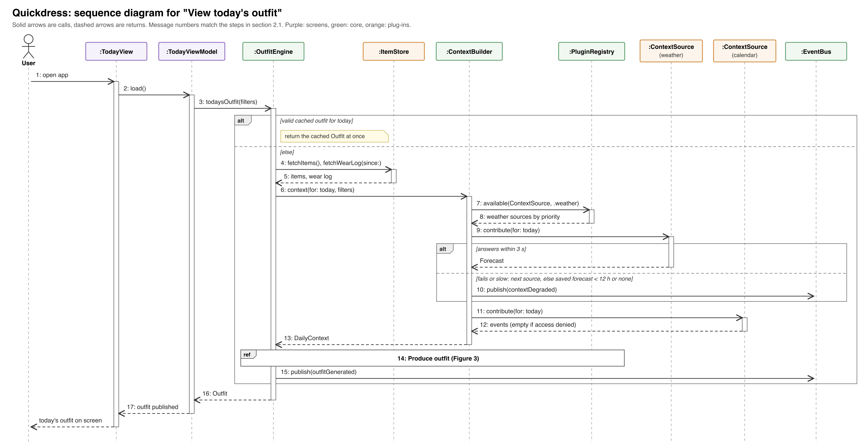
Figure 2. Sequence diagram for "View today's outfit" (FR-05, FR-08, FR-11, NFR-01, NFR-03). The step inside the engine is shown in Figure 3.
Figure 2 shows the main use case. The numbers in brackets are the message numbers in the figure.
- The user opens the app and TodayViewModel.load() calls OutfitEngine.todaysOutfit(filters) (1 to 3).
- If an outfit was already generated today and nothing it depends on has changed, the engine returns it from its cache at once. The cache is saved through the ItemStore, so it survives a relaunch and the screen is never blank (NFR-01). The rest of the steps run only when there is no valid cached outfit.
- The engine loads the items and the wear log for the no-repeat period from the ItemStore (4, 5).
- It asks ContextBuilder for today's DailyContext (6). The builder asks the registry for the available weather sources in priority order (7, 8) and calls the first one (9). If it fails or takes more than 3 seconds, the builder tries the next one. If every source fails, it uses the last saved forecast if it is less than 12 hours old, and otherwise uses no forecast. Either way it publishes contextDegraded, and the Today screen shows a badge (10). If location permission is denied, the weather sources report themselves unavailable and the outfit is chosen for mild weather, with a note on screen.
- The builder reads today's events from the calendar source (11, 12). If calendar access is denied, the list is empty and formality comes only from the filters (NFR-07). It then works out the day's formality level (section 2.2) and returns the context (13).
- The engine runs the pipeline and the recommenders (14), shown in detail in Figure 3, saves the result as today's outfit and publishes outfitGenerated (15). The ViewModel returns the outfit to the view, which draws it (16, 17).
Swapping a piece (FR-06) calls OutfitEngine.alternatives(for: slot). The engine returns the next three items for that slot in the rule-based ranking, keeping the other pieces fixed. Swaps never call Gemini, so they are instant and free. Asking for a new outfit (FR-07) runs the pipeline again with the current outfit added to the excluded combinations. Marking an outfit as worn (FR-09) calls OutfitEngine.markWorn(), which writes a WearRecord through the ItemStore and publishes outfitWorn.

2.2 Inside the outfit engine: the pipeline and the recommender plug-ins
The engine is a pipe-and-filter pipeline. Each stage takes the candidate items for every slot and passes a smaller set to the next stage. Figure 3 shows both cases: Gemini available and answering, and Gemini off, offline or failing, when the rule-based plug-in answers.
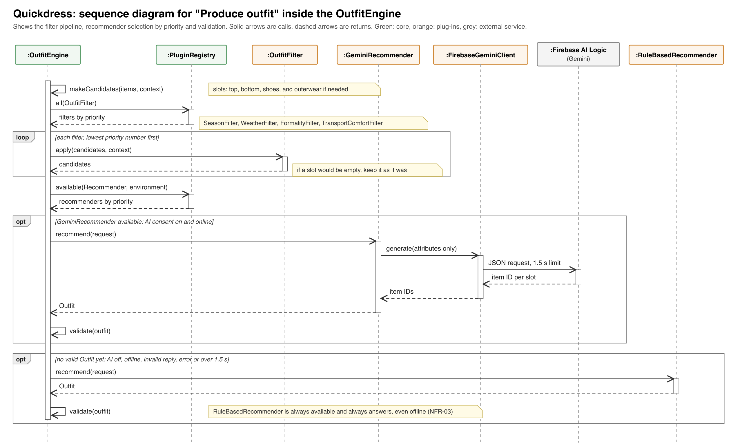
Figure 3. Sequence diagram for "Produce outfit" inside the OutfitEngine: filter pipeline, recommender selection by priority, and validation (FR-05, FR-08 to FR-11, FR-22, NFR-02, NFR-03, NFR-05, NFR-08).

Stage 1: candidates
Items are grouped into slots: top, bottom, shoes and, when needed, outerwear. Accessories are not part of this term's outfits. Outerwear is needed when the day's average apparent temperature is below 17 °C or the chance of rain is 50% or more.

Stage 2: filters
Every registered filter runs in priority order. If a filter would leave a slot empty, the engine keeps that slot as it was before the filter and notes that the filter was relaxed. This is why the app always produces an outfit as long as the wardrobe has at least one top, one bottom and one pair of shoes.
Filter | Rule
SeasonFilter | Keeps items whose seasons include the current one. Seasons follow the calendar months: December to February is winter, March to May spring, June to August summer and September to November autumn.
WeatherFilter | Works out a target warmth level from the average apparent (feels-like) temperature between 08:00 and 20:00: 30 °C and above gives 1, 24 to 29 °C gives 2, 17 to 23 °C gives 3, 10 to 16 °C gives 4, and below 10 °C gives 5. Keeps tops, bottoms and outerwear within one level of the target. With no forecast, the target is 3.
FormalityFilter | Keeps items within one level of the day's formality. The day's formality is the override from the filters if the user set one. Otherwise it is 4 if any event today is tagged formal by the user or its title contains a formality keyword, and 2 if not.
TransportComfortFilter | When the transport mode is walking or public transport, removes shoes with comfort below 3. When the comfort priority is high, removes every item with comfort below 3.
Table 5. The four filters in pipeline order.
The formality keywords are kept in one file, FormalityKeywords.swift, and matching ignores case. The first list is: interview, presentation, defense, defence, viva, conference, ceremony, graduation, wedding, formal, and the Arabic words مقابلة (interview), عرض (presentation), مؤتمر (conference), حفل (ceremony), تخرج (graduation) and فرح (wedding). Risk R7 covers the cases this list will miss.

Stage 3: recommenders
The engine builds an OutfitRequest with the filtered candidates, the context, and the combinations worn within the no-repeat period, which are excluded. It then asks the available recommenders in priority order. Each answer is checked: every slot that is needed must have exactly one item, every item must come from the candidates, and the combination must not be excluded. If an answer fails the check, throws an error or takes longer than 1.5 seconds, the engine asks the next recommender. The rule-based recommender is always last and always answers, so the app needs no network to produce an outfit (NFR-03).
The rule-based recommender scores each candidate on its own, keeps the best five per slot, and then scores the combinations:
- Item score = 0.4 × warmth fit + 0.3 × formality fit + 0.2 × (comfort ÷ 5) + 0.1 × freshness. Warmth fit is 1 minus the gap between the item's warmth and the target, divided by 4. Formality fit works the same way. Freshness is the number of days since the item was last worn, capped at 14 and divided by 14; an item never worn scores 1.
- Combination score = 0.7 × the average item score + 0.3 × the colour score. The colour score is the average over every pair of pieces in the outfit, read from a 12 × 12 colour table. Any colour paired with a neutral (black, white, grey, navy, beige) scores 1.0. Two pieces of the same non-neutral colour score 0.6. Pairs listed as clashing (red with pink, red with green, orange with pink, purple with yellow) score 0.2. Every other pair scores 0.5. The full table is written in Sprint 2 in ColourTable.swift.
- Five candidates in each of four slots give at most 625 combinations, however large the wardrobe is, which keeps generation under the one-second limit in NFR-05. Ties go to the combination with the higher freshness.
The weights above are the starting values. They are constants in one file, ScoringWeights.swift, and the team changes them only once, after the Sprint 2 usability test (Table 6), based on which outfits the testers rejected.
Worked example. The forecast gives an average apparent temperature of 21 °C with a 10% chance of rain, and the calendar has "Group presentation" at 10:00. The target warmth is 3, no outerwear is needed, and the formality is 4 because of the keyword "presentation". SeasonFilter, WeatherFilter and FormalityFilter leave, say, 6 tops, 4 bottoms and 3 pairs of shoes. If Gemini is turned off or the phone is offline, the rule-based recommender scores the 6 × 4 × 3 = 72 combinations and returns the best one that was not worn in the last 7 days.

2.3 Adding a clothing item
Changed in rev. 2. This section now describes the flow as built in Sprint 1. Figure 5 in section 7.4 shows it as a sequence diagram.
The Wardrobe screen's Add button opens a sheet with one button per available image source, camera first (AddItemFlow keeps the sources sorted by priority). If the camera has not been allowed yet, the app first shows its own short note saying why it needs the camera, and only then lets iOS ask (NFR-07). If the camera was refused, the sheet says so and offers the photo library and a link to Settings. The source returns the photo as JPEG data, scaled so that its long edge is at most 1600 pixels.
The New item screen opens with the photo. SubjectLifter cuts the garment out of its background on the phone (FR-17), and ItemAnalyzer suggests the category, colour, ratings and seasons (FR-13). Suggestions fill only the answers the user has not given yet, and the screen says they were filled in on the phone and should be checked. The user can change any answer, use the original photo instead of the cut-out, or retake the photo. Save stays off until the category, colour and at least one season are set.
WardrobeManager.addItem validates the attributes, gives the item the next tag number, asks the PhotoStore to write the photo and gets back a reference, then saves the item with that reference through the ItemStore. If saving the item fails, the manager deletes the photo it has just written, so no orphan files are left behind (NFR-06). It then publishes itemSaved, and the wardrobe grid reloads. Editing and deleting are described in section 7.5.

The Gemini plug-in and what it sends
GeminiRecommender reports itself available only when the AI switch is on and the phone is online. The switch is off by default, and the Settings screen explains in one sentence what is sent before the user can turn it on. This is the explicit consent that NFR-02 requires. When it runs, its client, FirebaseGeminiClient, sends:
- for each candidate item that passed the filters: its ID, category, colour, warmth, formality, comfort and seasons;
- for the day: the target warmth, whether outerwear is needed, the formality level, the transport mode and the comfort priority;
- the excluded combinations, as lists of item IDs.
It never sends photos, item names, calendar event titles or the user's location. Gemini is asked for structured JSON output that names one item ID per slot. The engine's check (stage 3) rejects any reply that does not fit. The model name is stored in Firebase Remote Config, so it can be changed without an app update. The plug-in uses Firebase AI Logic rather than calling the Gemini API directly, because a direct call would mean shipping an API key inside the app, where it can be extracted. Firebase keeps the key on Google's side and uses App Check (App Attest on iOS) to accept requests only from genuine copies of our app.

2.4 Alternatives considered
Alternative | Why we did not choose it
Layered architecture (our first version) | It grouped components by technical level, but it had no place for the main thing Quickdress does: choosing between interchangeable sources and recommenders at run time, with a fallback when one fails. That logic was spread across a relaxed set of layers in which ViewModels could skip the domain layer. The instructor also judged it too simple for the app.
Hexagonal (ports and adapters) | Close to what we have, but it expects one adapter per port, chosen when the app is built. We need several plug-ins per contract, chosen at run time by priority and availability, which is what a microkernel's registry provides.
Event-driven architecture on its own | Showing today's outfit is a request that needs an answer within 2 seconds (NFR-01). Building that from events and handlers would make the main flow hard to follow and test. We use events only for notifications (Table 4).
Client and server with our own backend | It would allow syncing and a server-side model, but it breaks on-device privacy (NFR-02), needs hosting and user accounts, and adds a second codebase. iCloud sync is out of scope this term (FR-21).
Model, View, Controller (MVC) for the screens | SwiftUI has no view controllers, so in practice the logic ends up inside the views, where it is hard to test. MVVM fits SwiftUI's @Observable data binding directly.

3 Quality attributes and how we will test them
Table 6 shows how the architecture meets each non-functional requirement in scope, and how and when we will check it. Every test runs in the sprint named, and its result is recorded in the sprint's test log in the GitHub repository (docs/test-log.md).
Requirement | How the architecture addresses it | Test: when, how, and the pass mark
NFR-01  Outfit visible within 2 s | The engine's cache returns today's outfit at once. The pipeline runs off the main thread. Recommenders other than the rule-based one get at most 1.5 s, and context sources 3 s each. | Sprint 2. Launch-to-outfit time measured with Instruments (os_signpost markers) on the oldest iPhone the team has, with a 200-item test wardrobe created by TestWardrobeFactory. Pass: under 2 s in 9 of 10 cold launches.
NFR-02  Data stays on the device | Every store is local. The only plug-in that sends wardrobe data is GeminiRecommender, it sends attributes only, and it is unavailable without consent. Weather plug-ins send only an approximate location. | Sprint 3. Run the app through the Proxyman proxy with consent off and on. Pass: with consent off, only weather requests appear; with it on, the Gemini request contains none of the fields listed as never sent (section 2.3).
NFR-03  Works offline | The rule-based recommender is always the last plug-in and needs no network. The context builder falls back to the saved forecast or to defaults. | Every sprint demo, plus an XCTest that registers only failing context sources. Pass: in airplane mode the wardrobe opens and an outfit appears.
NFR-04  First outfit within 5 minutes | Two tabs (Today, Wardrobe). The Today screen shows an Add item button, not an error, until a top, a bottom and shoes exist. | End of Sprint 2. Five people from outside the team, given a phone with an empty wardrobe and no instructions. Pass: at least 4 of 5 see an outfit within 5 minutes.
NFR-05  Under 1 s for 200 items | The shortlist of five per slot caps the work at 625 combinations (section 2.2). The scorer is a pure Swift function. | From Sprint 2, an XCTest measure test on 200 generated items, run by GitHub Actions on every pull request. Pass: average under 1 s.
NFR-06  No data lost | Photo first, item second, with rollback. Files in Application Support, which iOS does not clear. | End of every sprint: force-quit during a save, and install the new build over the previous one. Pass: every item and photo is still there and no orphan files exist.
NFR-07  Permissions on first use | Each plug-in asks for its own permission the first time it is used and reports itself unavailable if it is denied. The core treats an unavailable plug-in the same as a failed one. | End of Sprints 2 and 3: deny camera, location and calendar in turn. Pass: the app still adds items from the library and still shows an outfit, with the matching note.
NFR-08  Swappable recommender | Recommenders are plug-ins behind one contract. The ViewModel never knows which one answered. | From Sprint 2, an XCTest registers a fake recommender with a higher priority. Pass: its outfit is shown without any change to the app's code.
Table 6. Non-functional requirements, the decisions that meet them, and the test plan.
Changed in rev. 2. Sprint 1 already checked parts of three of these. NFR-07: the camera note, the iOS permission alert and the camera-off page were tested in the Simulator. NFR-06: items survived relaunching and reinstalling the app (a force-quit during a save is still to do). NFR-02: the cut-out and the suggestions run on the phone and the app makes no network call. NFR-09 is not formally tested, but a check at a large Dynamic Type size found tags spilling off the photos, which was fixed.
NFR-09 to NFR-11 are not formally tested this term, but the design supports them. Standard SwiftUI controls work with VoiceOver and Dynamic Type, and every item photo gets an accessibility label made from its category and colour. Strings go in a String Catalog so Arabic can be added later. The deployment target is iOS 17, which SwiftData and @Observable need anyway.

4 Architectural and design patterns
Four architectural patterns shape the app: the microkernel as a whole, pipe and filter inside the engine, publish and subscribe for events, and MVVM for the screens. Six design patterns shape individual parts. For each one, the table gives what the pattern is, where we use it, and why it suits Quickdress.

4.1 Architectural patterns

Microkernel (plug-in architecture)
What it is | A minimal core system holds the stable rules and a registry. Optional, replaceable features are plug-ins that implement contracts defined by the core.
Where it is used | QuickdressCore with PluginRegistry, and the five kinds of plug-in contract and their plug-ins (Tables 2 and 3, Figure 1).
Why it fits | Quickdress's variability is in its interchangeable parts: two weather sources, two recommenders with a fallback, two image sources and four filters, with more already in the backlog. Each becomes a plug-in, so adding one (for example OpenMeteoSource if WeatherKit is not available) changes no core code and no screen.

Pipe and filter
What it is | Data passes through a sequence of independent stages, each of which takes input and produces output for the next stage.
Where it is used | The outfit engine: candidates, then SeasonFilter, WeatherFilter, FormalityFilter and TransportComfortFilter, then the recommenders, then validation (section 2.2, Figure 3).
Why it fits | Each rule of the recommendation is a small stage that can be tested alone with a handful of items. A new rule, such as the planned laundry filter (FR-20), is one more stage.

Publish and subscribe (event bus)
What it is | Components publish events to a bus without knowing who receives them. Subscribers register for the events they care about.
Where it is used | EventBus and the six events in Table 4.
Why it fits | When an item is deleted, the engine, the wardrobe screen and today's outfit all need to react. With events, WardrobeManager does not need to know about any of them.

Model, View, ViewModel (MVVM)
What it is | The View displays state, the ViewModel holds that state and the actions on it, and the Model is the data. The View observes the ViewModel and redraws when the state changes.
Where it is used | Every screen in the host app: TodayView with TodayViewModel, WardrobeView and AddItemView with WardrobeViewModel, FiltersView with FiltersViewModel, and SettingsView with SettingsViewModel. ViewModels are @Observable classes.
Why it fits | SwiftUI is built around this kind of binding. ViewModels can be tested without any UI, and they depend only on the core's services.

4.2 Design patterns

Strategy
What it is | A family of interchangeable algorithms behind one interface, so the caller can use any of them without knowing which.
Where it is used | The Recommender contract, with RuleBasedRecommender and GeminiRecommender. The ContextSource contract, with WeatherKitSource and OpenMeteoSource.
Why it fits | NFR-08 asks for this directly. The engine picks the strategy at run time from the registry, by priority and availability.

Plugin and Registry
What it is | Plugin links an implementation to an interface at configuration time rather than in the code that uses it. A registry is a well-known object that other objects use to find those implementations.
Where it is used | QuickdressApp registers every plug-in in one place. PluginRegistry.available(Recommender.self) returns the available recommenders in priority order.
Why it fits | The choice of plug-ins is made in one file, so the order of the fallback and the set of filters is configuration, not code spread across classes.

Adapter
What it is | A class that wraps an existing interface so it matches the interface a client expects.
Where it is used | WeatherKitSource, OpenMeteoSource, EventKitCalendarSource, CameraSource, PhotoLibrarySource and FirebaseGeminiClient wrap Apple, Google and Open-Meteo interfaces and convert their types into our Forecast, CalendarEvent and JPEG data.
Why it fits | SDK types never reach the core, which is why the core can stay Foundation-only.

Repository
What it is | An object that behaves like a collection of domain objects and hides how they are stored.
Where it is used | The ItemStore contract and SwiftDataItemStore, which keeps its own @Model records and maps them to the domain types.
Why it fits | All queries and the SwiftData ModelContext live in one plug-in. Tests use an in-memory store. Moving to Core Data (risk R8) or CloudKit (FR-21) means writing one new plug-in.

Observer
What it is | An object notifies its observers automatically when its state changes.
Where it is used | SwiftUI views observe their @Observable ViewModels. The event bus applies the same idea between the core and the ViewModels.
Why it fits | It keeps the screens in step with the data without the core ever calling a view.

Dependency injection
What it is | Objects receive the things they depend on from outside instead of creating them.
Where it is used | QuickdressApp creates the registry, the event bus, the plug-ins and the core services, and passes the services to the ViewModels through their initialisers.
Why it fits | It lets tests and previews use fakes for every plug-in, which is how the tests in Table 6 run without a network or real permissions.

5 Detailed design: class diagram
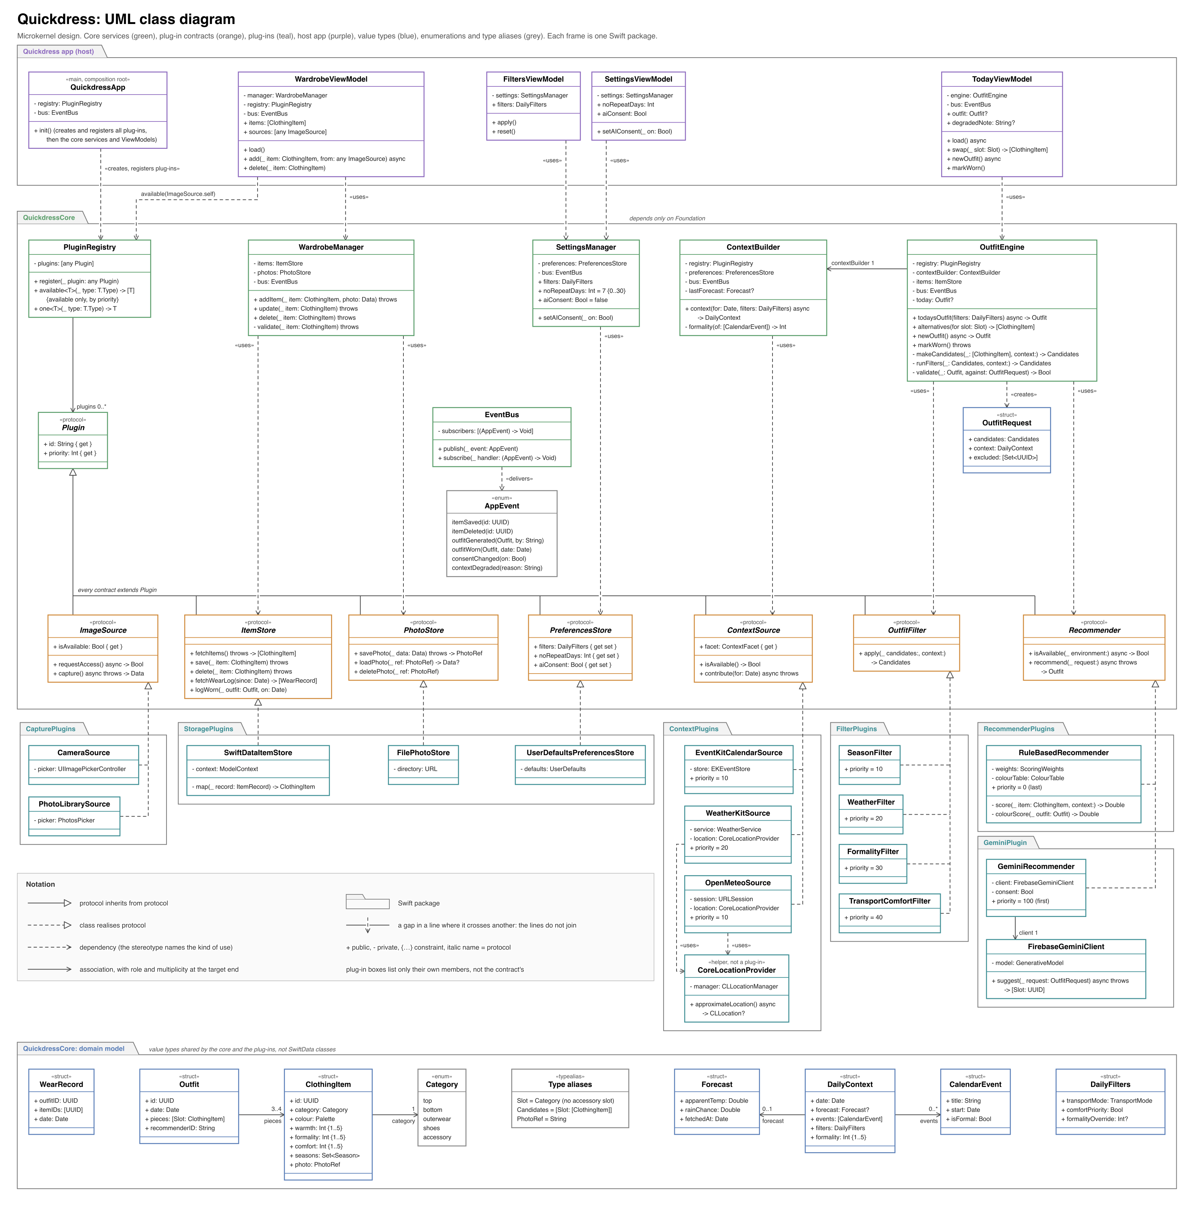
Figure 4. UML class diagram (Swift types). The components in Figure 1 are made up of these classes.
Table 7 maps each component in Figure 1 to its classes in Figure 4, and names the Swift package each belongs to.
Component | Package | Classes in Figure 4
PluginRegistry | QuickdressCore | Plugin, PluginRegistry
EventBus | QuickdressCore | EventBus, AppEvent
WardrobeManager | QuickdressCore | WardrobeManager
ContextBuilder | QuickdressCore | ContextBuilder
OutfitEngine | QuickdressCore | OutfitEngine, OutfitRequest
SettingsManager | QuickdressCore | SettingsManager
Plug-in contracts | QuickdressCore | ImageSource, ItemStore, PhotoStore, PreferencesStore, ContextSource, OutfitFilter, Recommender
Domain model | QuickdressCore | ClothingItem, Outfit, WearRecord, DailyContext, DailyFilters, Forecast, CalendarEvent, Category, Slot
Capture plug-ins | CapturePlugins | CameraSource, PhotoLibrarySource; helpers SubjectLifter, ItemAnalyzer and ImageScaler (built in Sprint 1, drawn in Figure 7)
Storage plug-ins | StoragePlugins | SwiftDataItemStore, FilePhotoStore, UserDefaultsPreferencesStore
Context plug-ins | ContextPlugins | WeatherKitSource, OpenMeteoSource, EventKitCalendarSource, CoreLocationProvider
Filter plug-ins | FilterPlugins | SeasonFilter, WeatherFilter, FormalityFilter, TransportComfortFilter
Recommender plug-ins | RecommenderPlugins, GeminiPlugin | RuleBasedRecommender, GeminiRecommender, FirebaseGeminiClient
Screens (host app) | Quickdress app | TodayViewModel, WardrobeViewModel, FiltersViewModel, SettingsViewModel, QuickdressApp; built in Sprint 1: WardrobeViewModel, CheckInViewModel, AddItemFlow (Figure 7)
Table 7. Mapping from components to packages and classes.
GeminiRecommender has its own package so that the Firebase SDK is linked only into that package. Every contract is drawn with the plug-ins that realise it. Dependencies that a class holds as a typed attribute, such as OutfitEngine.registry, are listed in the class box; only the main ones are drawn as arrows to keep the diagram readable.

6 Technical feasibility, build order and risks

6.1 Feasibility
Every in-scope feature uses well-documented first-party Apple frameworks: SwiftUI, SwiftData, PhotosUI, AVFoundation, WeatherKit, EventKit and Core Location, or the free Open-Meteo API. The only third-party SDK is Firebase, used only by the stretch Gemini plug-in. The hardest algorithm, the recommender, is rule-based scoring in plain Swift with the rules written out in section 2.2.
The microkernel adds two components that a layered design does not have: the registry and the event bus. Both are small. The registry is a dictionary from contract to a sorted list of plug-ins, and the bus is a list of handlers per event. We keep them under 150 lines together, and they are built and tested in the first week of Sprint 1, before any plug-in. Because plug-ins are compiled in, not loaded at run time, there is no dynamic loading to get right.

6.2 Build order
Each sprint ends at the next course milestone and delivers a working app that can be demonstrated. Table 8 lists what each sprint builds and the exit criteria that must pass before the sprint counts as done. Each person owns whole plug-ins, which is possible because plug-ins do not depend on each other.
Sprint | Components built | Exit criteria
Sprint 1 | Core: PluginRegistry, EventBus, WardrobeManager, domain model. Plug-ins: CameraSource, PhotoLibrarySource, SwiftDataItemStore, FilePhotoStore. Host app: Wardrobe screens. | FR-01 to FR-04 shown in the demo. Unit tests for WardrobeManager (validation and photo rollback) pass with in-memory stores. The NFR-06 test passes.
Sprint 2 | Core: ContextBuilder, OutfitEngine, SettingsManager. Plug-ins: OpenMeteoSource (and WeatherKitSource if R1 allows), SeasonFilter, WeatherFilter, RuleBasedRecommender, UserDefaultsPreferencesStore. Host app: Today screen. | FR-05 to FR-08 shown in the demo. The NFR-01, NFR-03, NFR-04, NFR-05, NFR-07 and NFR-08 tests in Table 6 pass.
Sprint 3 | Plug-ins: EventKitCalendarSource, FormalityFilter, TransportComfortFilter. Core: wear log and no-repeat period. Host app: Filters screen. | FR-09 to FR-11 shown in the demo. The NFR-02, NFR-03, NFR-06 and NFR-07 tests pass.
Sprint 3 stretch | In this order: saved outfits (FR-12), ItemAnalyzer (FR-13), GeminiRecommender and the Settings screen (FR-22). | Started only if every Sprint 2 exit criterion has passed when Sprint 3 begins. A stretch item that is not merged one week before the Sprint 3 demo is dropped. ItemAnalyzer ships only if it suggests the right category for at least 24 of 30 of the team's own items.
Table 8. Build order and exit criteria by sprint.
Changed in rev. 2. Sprint 1 result. FR-01 to FR-04 were shown working, plus FR-13 and FR-17 ahead of plan. The WardrobeManager unit tests for validation and photo rollback pass with in-memory stores (testInvalidItemIsNotSaved, testFailedItemSaveDeletesThePhotoAgain). The NFR-06 check passed in part: items and photos survived relaunching the app and installing a new build over the old one, but a force-quit in the middle of a save was not tried; it moves to Sprint 2. The plug-in registry was not built (section 7.1).
Every change goes through a pull request on GitHub. The main branch is protected: a pull request needs one approving review from another team member and a passing GitHub Actions run (build plus all tests) before it can be merged.
Changed in rev. 2. In Sprint 1 this rule was not yet enforced on GitHub. Two commits were pushed straight to main without building, and the app stopped compiling until pull request #2 fixed it. The team will turn on branch protection before Sprint 2 starts (Milestone 2 report, retrospective).

6.3 Risks
ID | Risk | Chance | Impact | Mitigation | Decided by
R1 | WeatherKit needs a paid Apple Developer Program membership ($99 a year). Without one, test installs also expire every 7 days. | High | High: blocks FR-08 | OpenMeteoSource (free for non-commercial use, no key) is built in Sprint 2 regardless. WeatherKitSource is added only if a membership exists, as a higher-priority plug-in. | Start of Sprint 2
R2 | Xcode runs only on macOS. A team member without a Mac cannot build or run the app. | Medium | High | Pair those members with Mac owners, or give them work that needs no Xcode: the colour table, the keyword list, the 200-item test data and the test plans in Table 6. | Start of Sprint 1
R3 | The team is learning Swift and SwiftUI during the project. | High | Medium | Sprint 1 is plain create, read, update and delete work. Each plug-in is small and has one owner. Every pull request is reviewed. | Ongoing
R4 | The plug-in structure is new to the team and could slow Sprint 1. | Medium | Medium | Registry and bus under 150 lines, built first with tests. No dynamic loading. After the Sprint 1 review, a change to a contract needs the agreement of the whole team in the pull request. | End of Sprint 1 week 1
R5 | Gemini replies may be wrong, slow or not valid JSON. | Medium | Low | Structured output, the engine's validation, a 1.5 s limit and the rule-based fallback. | Sprint 3 (stretch)
R6 | Gemini cost, quota or model names change. | Low | Low | Flash-Lite is Google's lowest-cost model in the family. The model name is in Remote Config. At most one call per generated outfit, and none for swaps. | Sprint 3 (stretch)
R7 | Detecting formality from calendar titles by keyword misses vague titles such as "Meeting". | High | Medium | The user can tag an event as formal, and the formality override always wins. The keyword list (section 2.2) is in one file. | Sprint 3
R8 | SwiftData is fairly new and has known bugs, especially with schema changes. | Medium | Medium | SwiftData is used only inside SwiftDataItemStore. If it fails the NFR-06 test twice, we replace that one plug-in with a Core Data version. | End of Sprint 1
R9 | Automatic category and colour suggestion (FR-13) may be inaccurate. | Medium | Low | Built in Sprint 1. On 9 test photos the category was right 6 times and the colour 8 times (after one fix). The user always checks the answers, and Save never relies on a suggestion alone. The 24 of 30 pass mark is measured on real items in Sprint 2. | Sprint 2
R10 | The iOS Simulator has no camera. | Certain | Low | CameraSource reports itself unavailable on the Simulator, so the photo library is used there. The camera is tested on a real phone. | Sprint 1
R11 | Event handlers could run in an unexpected order or trigger each other in a loop. | Low | Medium | Handlers run in subscription order on the main thread, may not publish the same event type, and each event has a unit test. | Sprint 1
R12 | Apple's Vision models (cut-out and classifier) do not run in the iOS Simulator. | Certain | Medium | The capture package's tests run on a Mac, where Vision works, with a real garment photo. The UI tests use a test photo source. The cut-out and suggestions are checked on a real iPhone in Sprint 2. | Start of Sprint 2
Table 9. Technical risks.
Core ML is no longer part of this term's plan. We have no training data, so a model could not be tested. The design keeps the option open: an on-device recommender would be one more plug-in (Table 3).

7 Sprint 1: lower-level design as built
New in rev. 2. This whole section is new in revision 2.
Sprint 1 built the wardrobe: adding items from the camera or the photo library, editing and deleting them, and browsing them in a filtered grid (FR-01 to FR-04), plus the cut-out and suggestions of FR-13 and FR-17. This section records the lower-level design of that code, where it differs from the design in sections 1 to 6, the user interface, and how it was tested.

7.1 Differences from the plan
Planned (sections 1 to 6) | As built in Sprint 1 | Why
PluginRegistry, built first, with tests. | Not built. QuickdressApp creates each plug-in and passes it in through initialisers. AddItemFlow keeps the available image sources sorted by priority itself. | Each contract had one or two plug-ins, so passing them in directly was simpler and still keeps the core free of plug-in code. The registry is needed once there are several weather sources, filters and recommenders, so it moves to Sprint 2.
EventBus with six events. | EventBus with itemSaved and itemDeleted. | The other four events belong to components that do not exist yet.
ItemAnalyzer as a Sprint 3 stretch goal. Background removal (FR-17) deferred. | Both built in Sprint 1: ItemAnalyzer and SubjectLifter. | Apple's Vision framework does both on the phone, with no network call and no API key, so they fit the privacy requirement (NFR-02) and took little time.
ClothingItem with the FR-02 attributes. | Two more fields: number (the tag number) and exactColour ("#RRGGBB"). | Every item shows a numbered tag, and the colour picker and the photo give an exact colour that one of 12 names cannot hold.
WardrobeFilter with category and colour. | Also seasons and a LevelBand for warmth, formality and comfort. | The attribute filters added to FR-04.
PhotoLibrarySource wraps SwiftUI's PhotosPicker. | It wraps PHPickerViewController, presented from UIKit. | AddItemFlow is not a view, so the picker is shown from code and its result returned with async/await. It still needs no Photos permission.
main is protected; every change goes through a reviewed pull request. | Not enforced yet. One direct push broke the build; pull request #2 fixed it. | Recorded in the Milestone 2 retrospective.
Table 10. Where the built code differs from the plan.

7.2 Capture plug-ins and helpers
The CapturePlugins package holds the two image sources and three helpers. The helpers are not plug-ins: they implement no contract and are called by the New item screen's view model.
Type | Responsibility
CameraSource | Implements ImageSource with the camera, through UIImagePickerController. Reports its permission state from AVCaptureDevice and asks for permission only when the user first chooses the camera. Priority 20.
PhotoLibrarySource | Implements ImageSource with PHPickerViewController, which runs outside the app and needs no Photos permission. Priority 10.
ImageScaler | Decodes photo data, scales it so the long side is at most 1600 pixels, and encodes JPEG, or PNG for a cut-out.
SubjectLifter | Cuts the garment out with Vision's VNGenerateForegroundInstanceMaskRequest and returns it as a PNG with a transparent background, cropped to the garment. Returns nothing if Vision finds no subject, and the screen then keeps the full photo.
ItemAnalyzer | Suggests the category, colour, ratings and seasons. Returns an ItemSuggestion in which any part may be empty.
Table 11. Types in CapturePlugins.
How ItemAnalyzer suggests the details. It works on a copy of the photo scaled to 600 pixels:
- Type and ratings. Vision's built-in image classifier (VNClassifyImageRequest) returns labels with a confidence. Labels below 0.3 are ignored. The first label found in a table of 29 garment labels gives the category and starting ratings, for example "jacket" gives outerwear with warmth 4, formality 3 and comfort 3, and "sneaker" gives shoes with warmth 3, formality 1 and comfort 5. Vision has no plain "shirt" or "trousers" label, so if it only says "clothing", a garment taller than 1.3 times its width is suggested as a bottom and anything else as a top, with every rating at 3. If no label matches, the category stays empty.
- Seasons. They follow the suggested warmth: 1 is summer, 2 spring and summer, 3 spring and autumn, 4 autumn and winter, 5 winter.
- Colour. The photo is reduced to 64 pixels on its long side. The analyzer takes the garment's pixels (the opaque pixels of a cut-out, or the middle 60% of a photo that was not cut out) and groups them into three colours with k-means (10 rounds). The centre of the largest group is the exact colour. It is named by the nearest of the 12 palette colours, measured in CIE Lab so that the distance follows how different the colours look.
Changed in rev. 2. The palette's reference colours are tuned to how garments photograph, which is darker and greyer than the colour names suggest. Testing in Sprint 1 (test case TC-16 in the Milestone 2 report) found faded denim, khaki chinos and a dark green beanie named grey or black. Blue, beige and green now each have a second reference point, as grey already had one for charcoal, and a regression test holds the measured colours. On the nine test photos the colour went from 5 right to 8 right.
Vision's models do not run in the iOS Simulator (risk R12). There, the cut-out returns nothing and the classifier returns no labels, so only the colour is suggested. The package's own tests run on a Mac, where Vision works.

7.3 Domain and storage changes
- ClothingItem.number: the tag number, shown as "No. 001". WardrobeManager.addItem gives each new item one more than the highest number in the wardrobe, and numberUnnumberedItems() numbers items saved before numbers existed.
- ClothingItem.exactColour: an optional "#RRGGBB" string. colour is always the nearest palette colour, which the outfit rules will use.
- RGB: an exact colour with conversion to and from hex and to CIE Lab. Palette.nearest(to:) names an RGB.
- WardrobeFilter: now also seasons (an item matches if it is worn in any selected season) and levels, a LevelBand (low 1 to 2, medium 3, high 4 to 5) for any of warmth, formality and comfort. Every part that is set must match.
- ItemRecord (SwiftData) stores the two new fields. FilePhotoStore names files .png for cut-outs and .jpg for photos, decided from the data's first bytes.

7.4 Adding an item
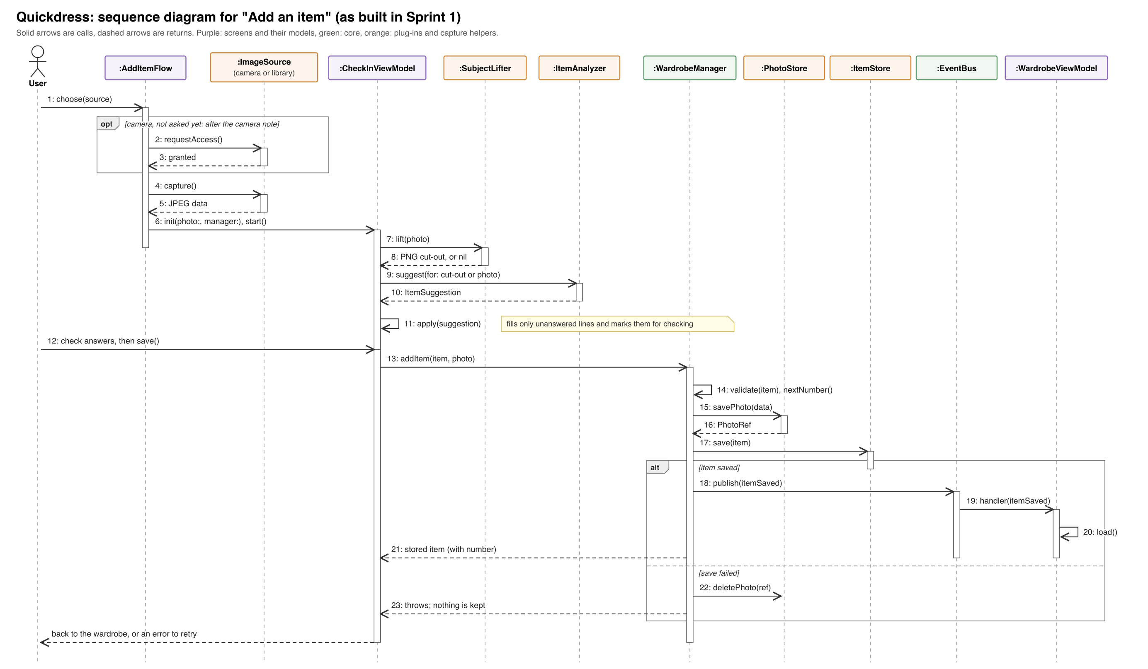
Figure 5. Sequence diagram for "Add an item" as built in Sprint 1 (FR-01, FR-02, FR-13, FR-17, NFR-06, NFR-07).
The numbers are the message numbers in Figure 5.
- The user chooses a source on the add sheet (1). If it is the camera and iOS has not asked yet, the app shows its own note first and then asks for permission (2, 3).
- The source returns the photo (4, 5). AddItemFlow creates the New item screen's CheckInViewModel and starts it (6).
- The view model asks SubjectLifter for a cut-out (7, 8) and ItemAnalyzer for suggestions, using the cut-out if there is one (9, 10). It applies the suggestions to the answers the user has not given (11).
- The user checks the answers and saves (12). WardrobeManager validates the item and gives it the next number (13, 14), saves the photo and then the item (15 to 17), and publishes itemSaved so the wardrobe grid reloads (18 to 21). If saving the item fails, the photo is deleted again and the screen shows an error with Try Again (22, 23).

7.5 Editing and deleting an item
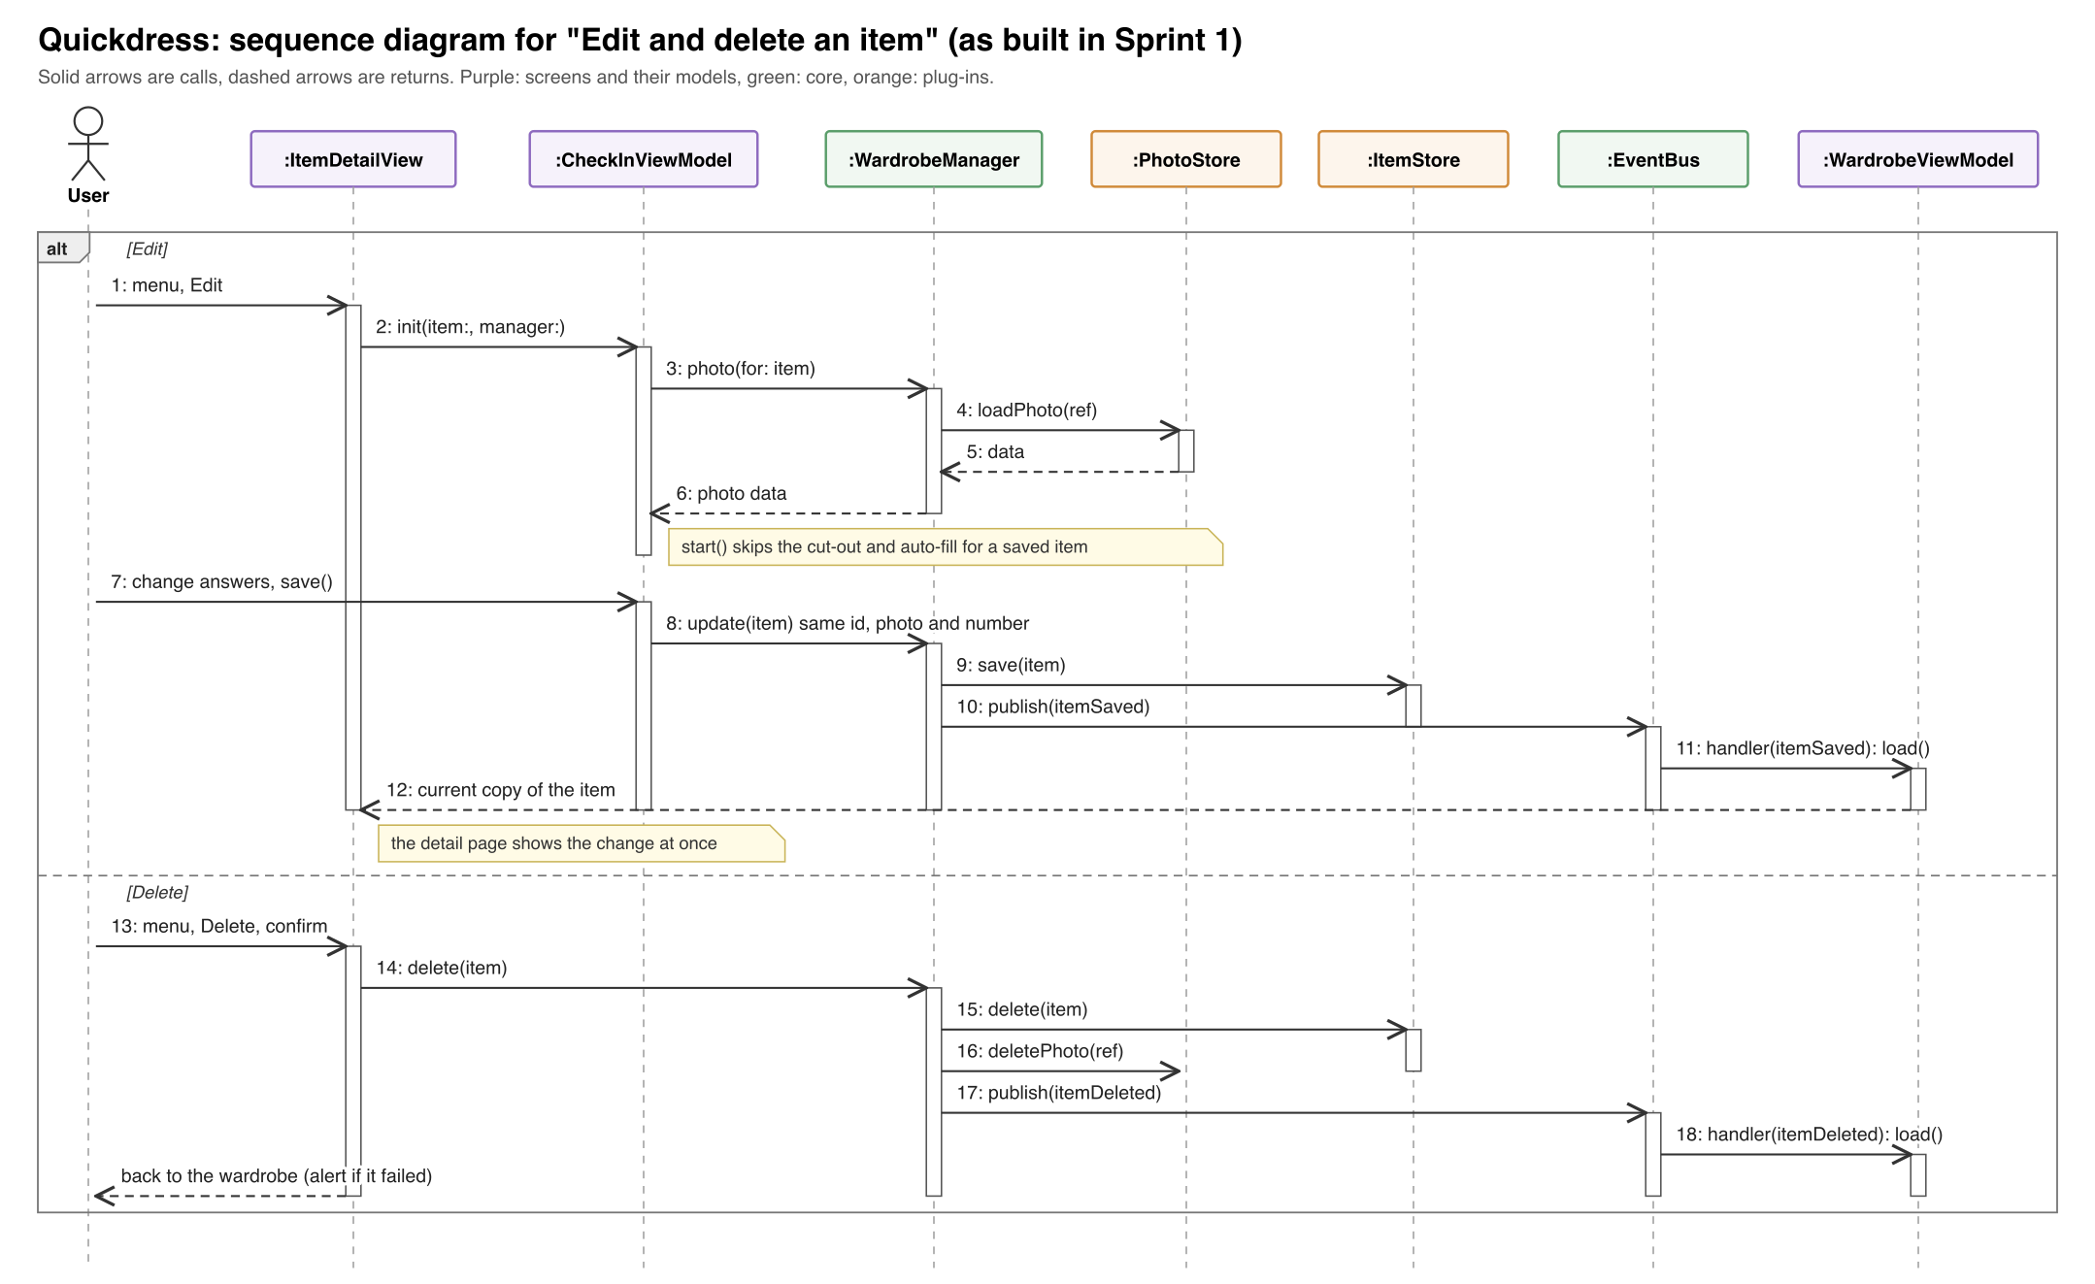
Figure 6. Sequence diagram for "Edit and delete an item" as built in Sprint 1 (FR-03).
The item detail page has a menu with Edit and Delete. Edit opens the same screen as New item, titled Edit item, with the saved answers and photo. It does not run the cut-out or the suggestions again and has no Retake button, so the saved photo is kept. Saving calls WardrobeManager.update, which keeps the item's id, photo and tag number. The detail page reads the wardrobe's current copy of the item, so the change shows as soon as the sheet closes.
Delete asks "Delete this piece?" first. WardrobeManager.delete removes the item, then its photo file, and publishes itemDeleted. If deleting fails, an alert says the piece is still in the wardrobe.

7.6 Class diagram of the built code
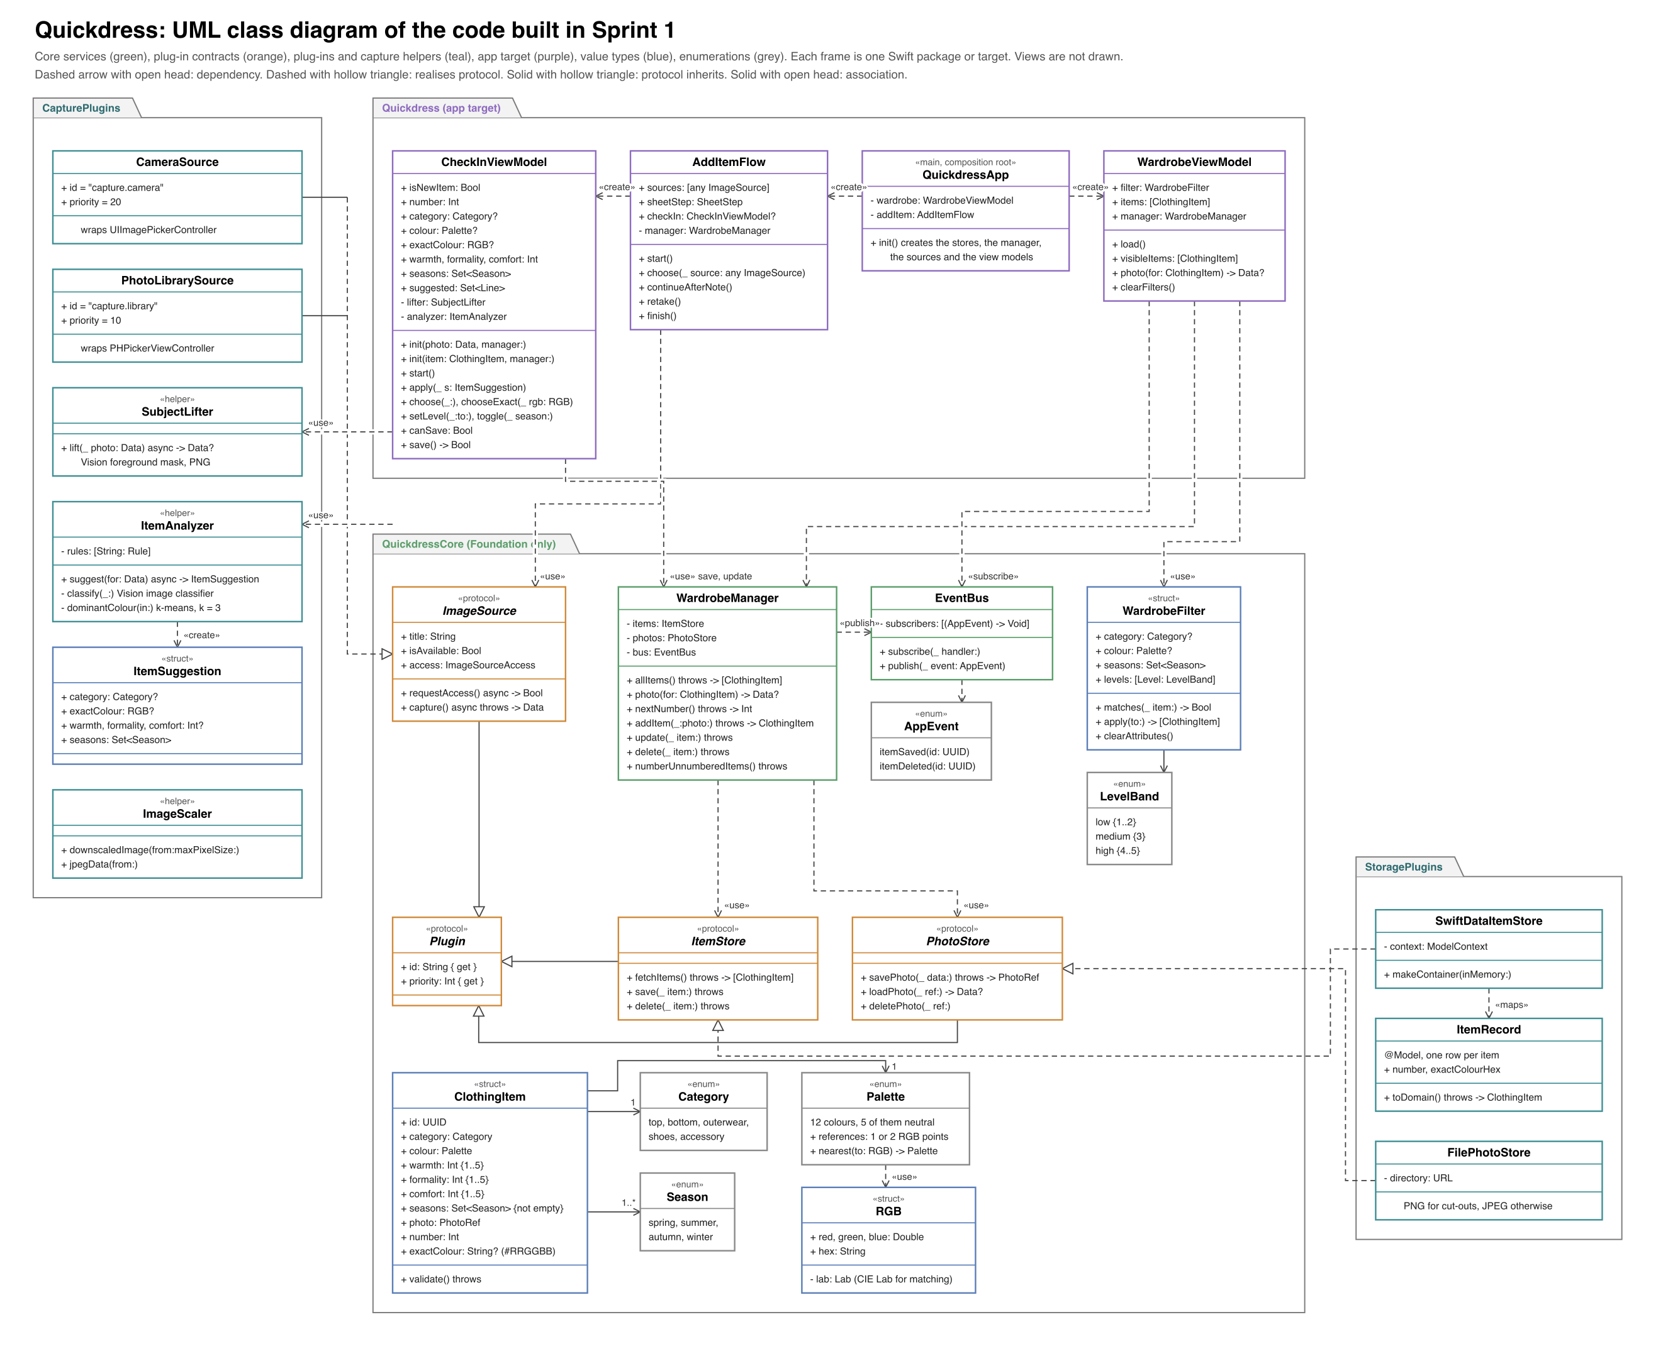
Figure 7. UML class diagram of the code built in Sprint 1. Views are not drawn. Figure 4 is the design for the whole term; this figure is what exists now.

7.7 User interface design
The app has one visual idea: a dry cleaner's claim ticket. Each garment carries a numbered pastel paper tag, details print like ticket lines, and the main action on a sheet is a black ticket stub. The screens keep standard iOS navigation, sheets, alerts, menus and the system colour picker, so they behave the way iPhone users expect.
Token | Value | Used for
Ground | #F3F1EC | Background of every screen and sheet
Paper | #FCFBF8 | Cards, receipts, unselected chips
Ink | #141414 | Text, selected chips, the stub button
Secondary ink | #57534C | Notes and secondary text
Stamp | #C2185B | Only the "Needed" label on an unanswered question
Tag colours | Top #BDE8D2, bottom #F7B9C8, outerwear #BFD9F2, shoes #D9C6F0, accessory #F9C9A6 | The tag on each garment, the category filter chips, and the selected category on the New item screen
Statement face | Pragati Narrow Bold | Screen titles, card titles, the stub label
Ticket face | Chivo Mono (Regular and Medium) | Tag numbers, chips, notes, receipt lines
Table 12. Design tokens. Both fonts are under the SIL Open Font License and are bundled with the app.
Screen | What it shows
Wardrobe | The title, tag-shaped filter chips for category and colour, a button for the other filters, and a two-column grid of garments with their numbered tags. With no items it shows one sentence and a "Check in your first piece" stub.
Filter sheet | Season chips and Any, Low, Medium and High bands for warmth, formality and comfort. The stub shows how many pieces match. Active filters appear on the Wardrobe as chips that remove themselves when tapped.
Add sheet | Two tickets, Take a photo and Choose from library, and the note that photos stay on the phone. The camera note and the camera-off page appear here when needed.
New item and Edit item | The garment with its tag (the tag takes the category's colour once chosen), Retake, then paper cards for category, colour (12 swatches and the system colour picker with its eyedropper), the three ratings as five squares each, and season chips. Cancel asks before discarding; Save stays off until every answer is set.
Item detail | The garment with its tag and a printed receipt of its details, including the exact colour. The menu holds Edit and Delete.
Table 13. Screens built in Sprint 1. Screenshots are in the Milestone 2 report.
Every control is at least 44 by 44 points and has a VoiceOver label; the ratings can be adjusted by swiping up and down with VoiceOver. Text uses Dynamic Type. The tags on the photos are capped at the default text size because they are decorative and their number is part of the item's VoiceOver label. The app is light mode only for now; dark mode is planned for Sprint 2.

7.8 Testing as run in Sprint 1
Table 14 lists the test levels used in Sprint 1. The Milestone 2 report lists every test case and its result.
Level | What it covers | Tool | Tests
Unit, core | Item validation (boundary values 0, 1, 5, 6), the event bus, WardrobeManager with in-memory stores, filters and bands, palette matching | XCTest | 40
Unit, storage | SwiftData records and the photo files, in memory and in a temporary folder | XCTest | 14
Unit, capture | Scaling, the cut-out and suggestions on a real garment photo (on a Mac) | XCTest | 7
Unit, app models | CheckInViewModel (new and edit) and WardrobeViewModel with in-memory stores | XCTest | 17
End-to-end UI | Add, cancel, edit then delete, and filtering, through the real screens with an in-memory store and a test photo source | XCUITest | 4
Manual system tests | Camera permission, the photo picker, persistence, large text, cut-out and suggestion accuracy on real photos | Simulator and Mac | See report
Table 14. Test levels in Sprint 1: 82 automated tests, all passing.
GitHub Actions runs the three packages' tests, builds the app and runs the app's unit tests on every push and pull request.

8 Conclusion
Changed in rev. 2. Sprint 1 built the wardrobe half of this design: the core's WardrobeManager, event bus and domain model, the capture and storage plug-ins, and the wardrobe screens, plus the on-device cut-out and suggestions. Section 7 records where the built code differs from the plan and why. The plug-in registry, the context builder and the outfit engine come next, in Sprint 2.
Quickdress is built as a microkernel. A small, Foundation-only core holds the wardrobe rules, the context builder, the outfit engine, a plug-in registry and an event bus. Everything that varies is a plug-in: image sources, stores, weather and calendar sources, outfit filters and recommenders. Inside the engine, a pipe-and-filter pipeline narrows the wardrobe, and recommenders are tried by priority with a rule-based plug-in that always answers, which is how the design meets the offline and privacy requirements while still allowing the opt-in Gemini step. The screens use MVVM and talk only to the core. Section 2.2 writes out the recommendation rules, Table 6 gives a test with a pass mark for each of NFR-01 to NFR-08, and Table 8 sets exit criteria for each sprint and a rule for when stretch goals are built.

